# Big Mountain Resort Recommendation Summary.

The primary objective of this data science initiative was to develop an effective pricing model tailored specifically for ski resort tickets within our market segment. Big Mountain (BMR) acknowledges the possibility of underutilizing its market position and seeks to optimize returns. A key challenge lies in understanding the significance of resort facilities in influencing visitor preferences and determining which features hold the highest value in terms of pricing.

During our data analyses we found that Adult weekend prices and below few features had significant impact in our regression models:

* Vertical Drop
* Snow Making in Ac
* Total # of Chairs
* Fast Quad Chairs
* # of Runs
* Longest Runs in Miles
* Trams
* Skiable Terrain in AC

Of the above Features, some features where BMR stands to take advantage of and increase their weekend Price from $81 are as follows:

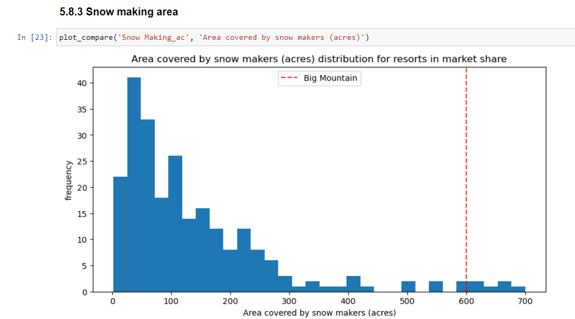

Big Mountain is very high up the league in Snow making area compared to the market.

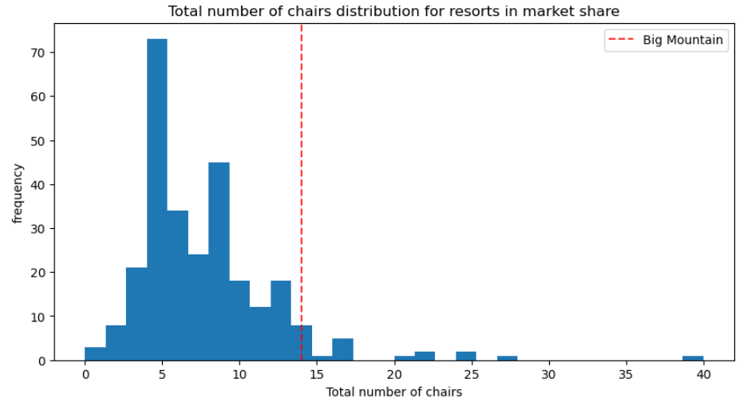

It’s also very high in # of chairs as a resort.

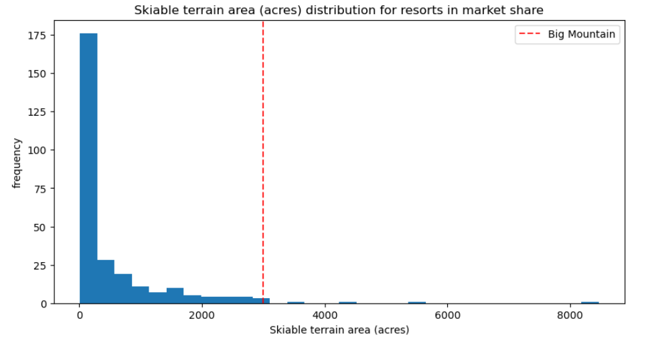Lastly among few others, BMR also amongst the resort with most skiable terrain.

Using the Forest regression model supported by unique facilities this resort offers, we could set the price at $95.87. Furthermore, With the expected mean absolute error of +/- $10.39, we can be confident that there is room to increase the price.

Lastly, BMR can also take up future improvements to increase Vertical drop by adding 150ft, adding another chair lift to bring skiers back up, and add 2 acres of snow to support a price increase by $9.90, resulting in $17.3 Million profit.